**Coffee Sales Analysis**

1. Calculating Week number from the Date Column

Query



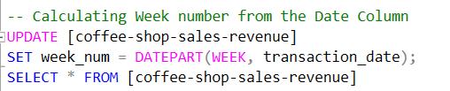

Output

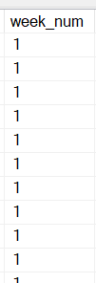

1. Calculating Total Sales from price and quantity column

Query

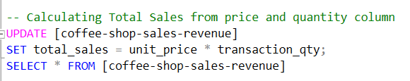

Output

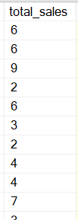

1. Calculating Previous Week Sales

Query

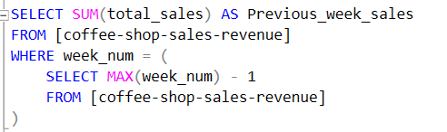

Output

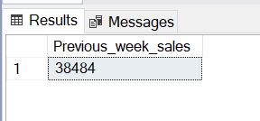

1. Calculating Current Week Sales

Query

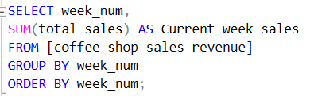

Output

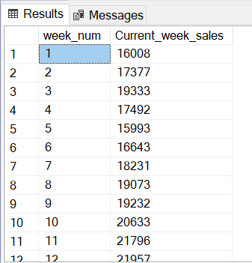

1. Calculating Total Sales Per Week

Query

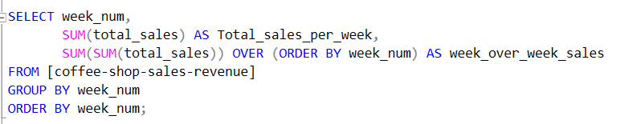

Output

